Mobile applications must meet high standards of quality and reliability to ensure a positive user experience. This bug report documents the issues identified in the Any.do mobile application during testing. These bugs need to be addressed to improve the app's functionality and user satisfaction.

Bug 1: Incomplete Language Translation

Description: When changing the app language to Arabic, the app is not fully translated. It contains a mix of Arabic and English, and some sentences intermittently switch between the two languages.

**Reproducible Steps:**

1. Go to Settings.
2. Change the language to Arabic.
3. Navigate through different sections of the app.

**Attachments:**

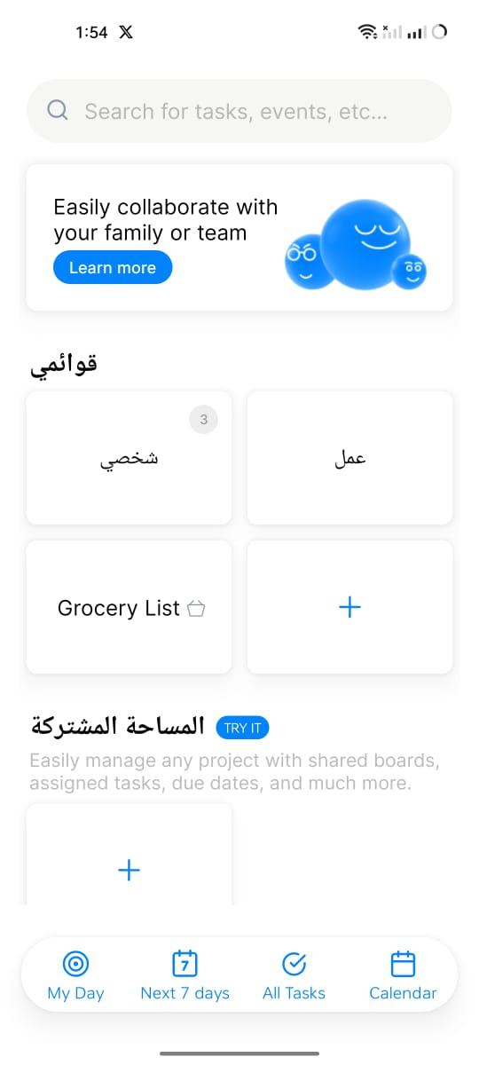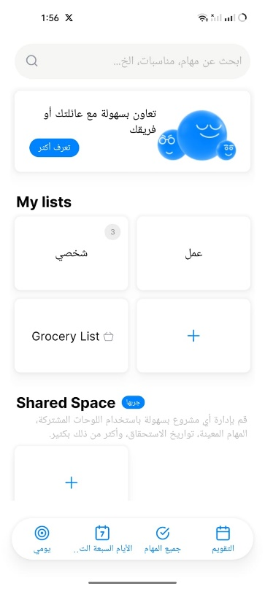

**Affected Devices:** iOS and Android

**Expected Result:** The app should display all text in Arabic without mixing with English.

**Actual Result:** The app displays a mix of Arabic and English, with some sentences switching languages intermittently.

**Network:** Any

**Severity:** Medium

**Priority:** High

**Impact**: Users experience inconsistent language display, affecting usability and user experience.

Bug 2: Navigation to General Settings

Description: The general settings are not accessible from the home page. Users need to navigate to the task section and click on the three dots to find the settings.

**Reproducible Steps:**

1. Open the app.
2. Try to find the general settings from the home page.
3. Navigate to the task part and click on the three dots to find settings.

**Attachments:**

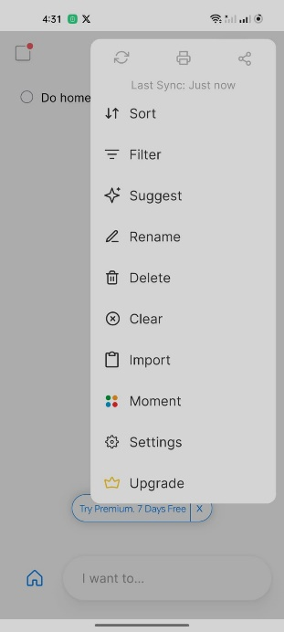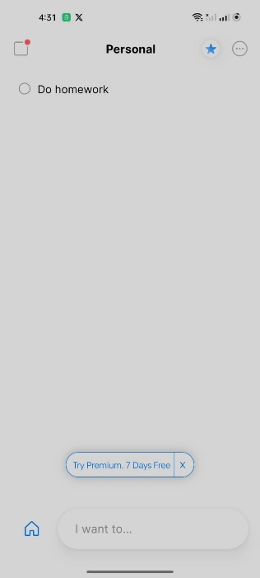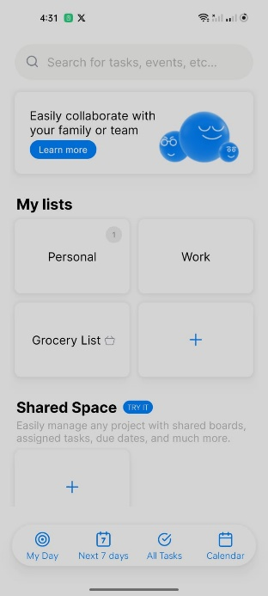

**Affected Devices:** iOS and Android

**Expected Result:** General settings should be accessible directly from the home page.

**Actual Result:** General settings are only accessible through the task section.

**Network:** Any

**Severity:** Low

**Priority:** Medium

**Impact:** Difficulty in finding settings may confuse users and hinder app configuration

Bug 3: Profile Image Upload Inconsistency

Description: The app allows uploading a video as a profile image on iOS but not on Android. Generally, uploading videos as profile images should not be allowed.

**Reproducible Steps:**

1. Go to Profile Settings on an iOS device.

2. Attempt to upload a video as a profile image.

**Attachments:**

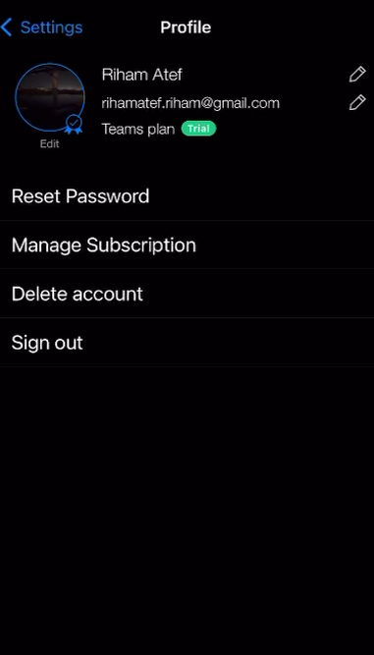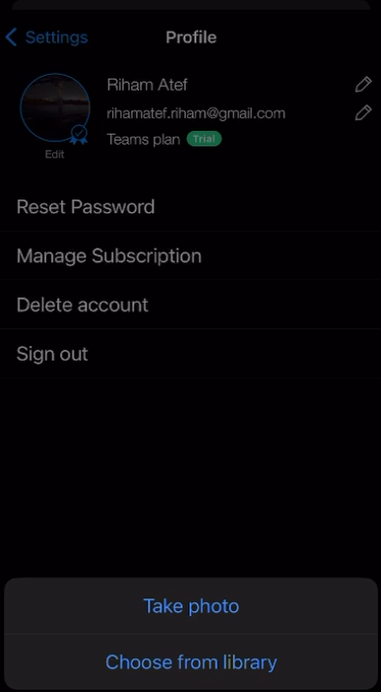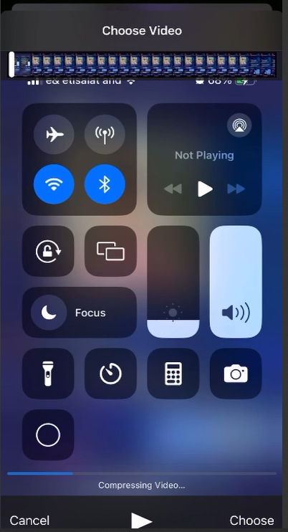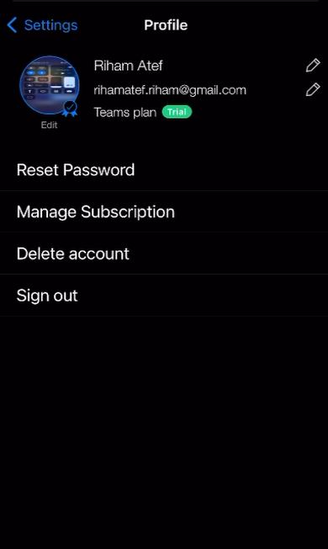

**Affected Devices:** iOS

**Expected Result:** The app should restrict uploading videos as profile images on both iOS and Android.

**Actual Result:** The app allows uploading videos on iOS but not on Android.

**Network:** Any

**Severity:** Low

**Priority:** Medium

**Impact:** Inconsistent functionality between platforms affects user expectations and experience.

Bug 4: Single File Selection for Task Attachments

Description: Users can only select one file at a time when attaching files to a task, which is inefficient if multiple files need to be attached.

**Reproducible Steps:**

1. Create a new task.
2. Open a task and try to attach multiple files.
3. Notice that you can only select one file at a time.

**Attachments:**

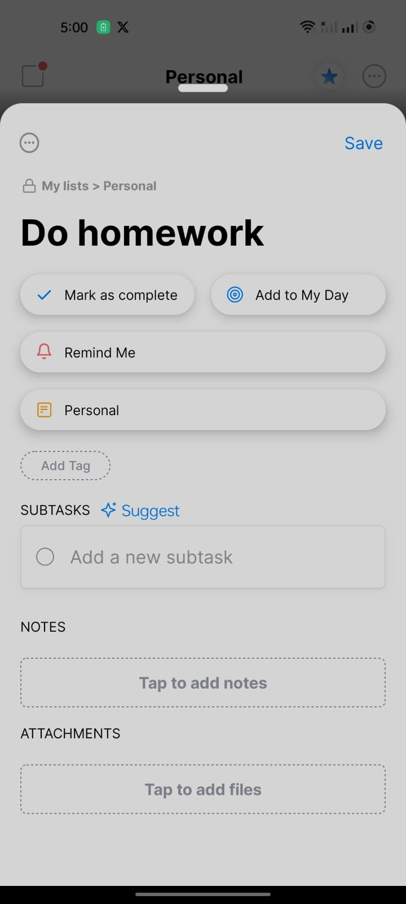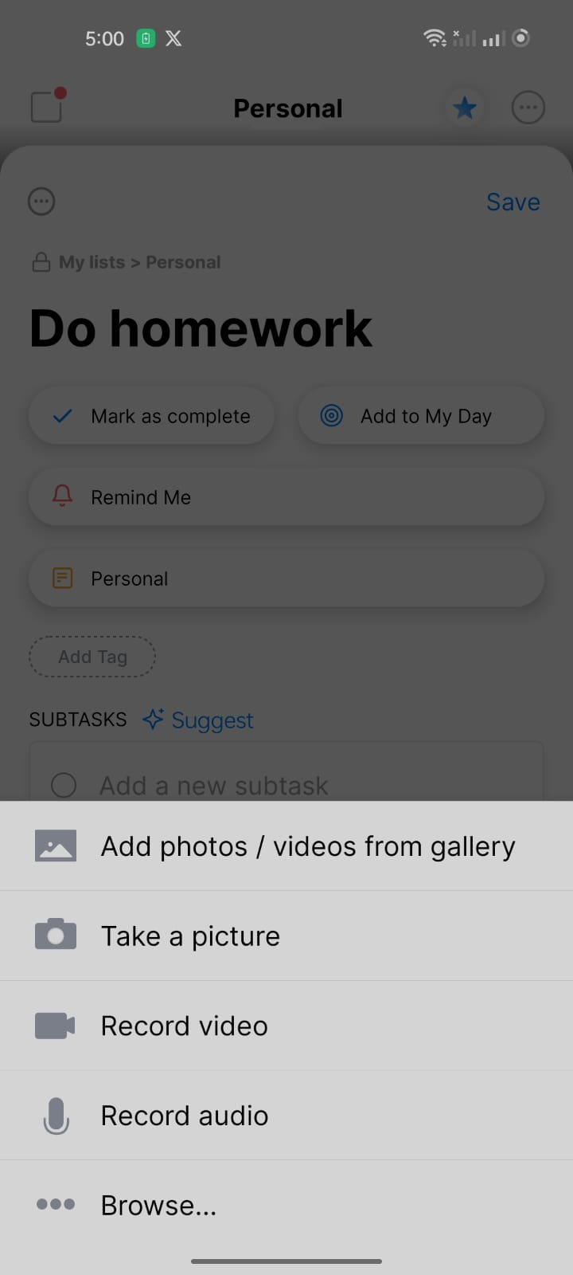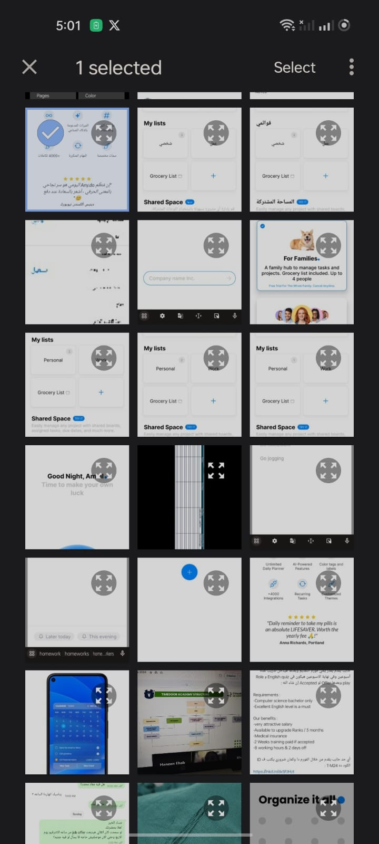

**Affected Devices:** iOS and Android

**Expected Result:** Users should be able to select and attach multiple files at once.

**Actual Result:** Users can only select one file at a time.

**Network:** Any

**Severity:** Medium

**Priority:** Medium

**Impact:** Inefficient attachment process frustrates users needing to attach multiple files.

Bug 5: Speech to Text Task Entry

Description: After registering or logging in for the first time, users can enter the first task using speech to text or by writing. However, subsequent tasks can only be entered by writing, despite having a speech setting.

**Reproducible Steps:**

1. Register or log in for the first time.

2. Enter the first task using speech to text.

3. Attempt to enter additional tasks using speech to text.

**Attachments:**

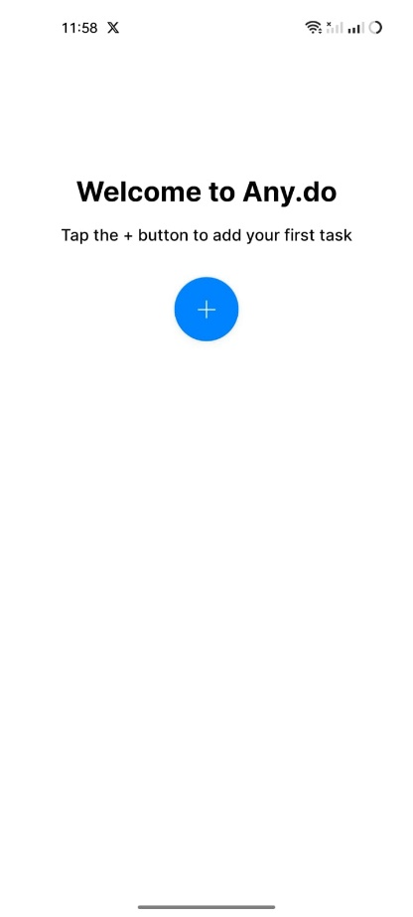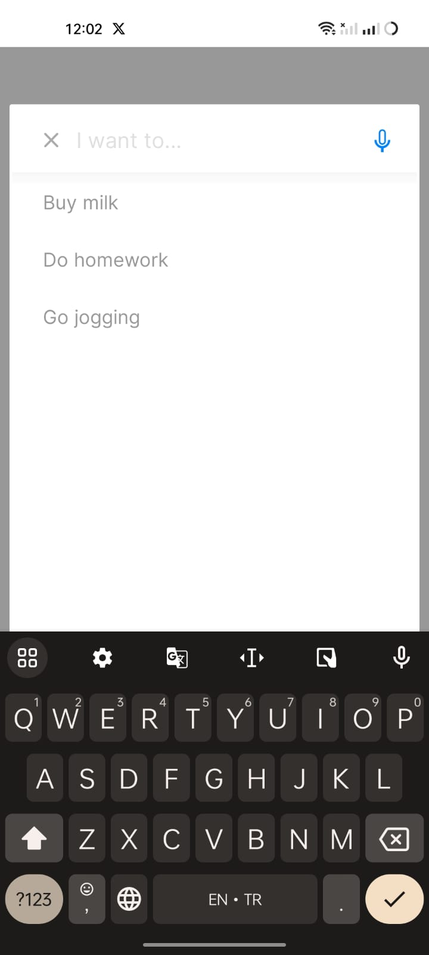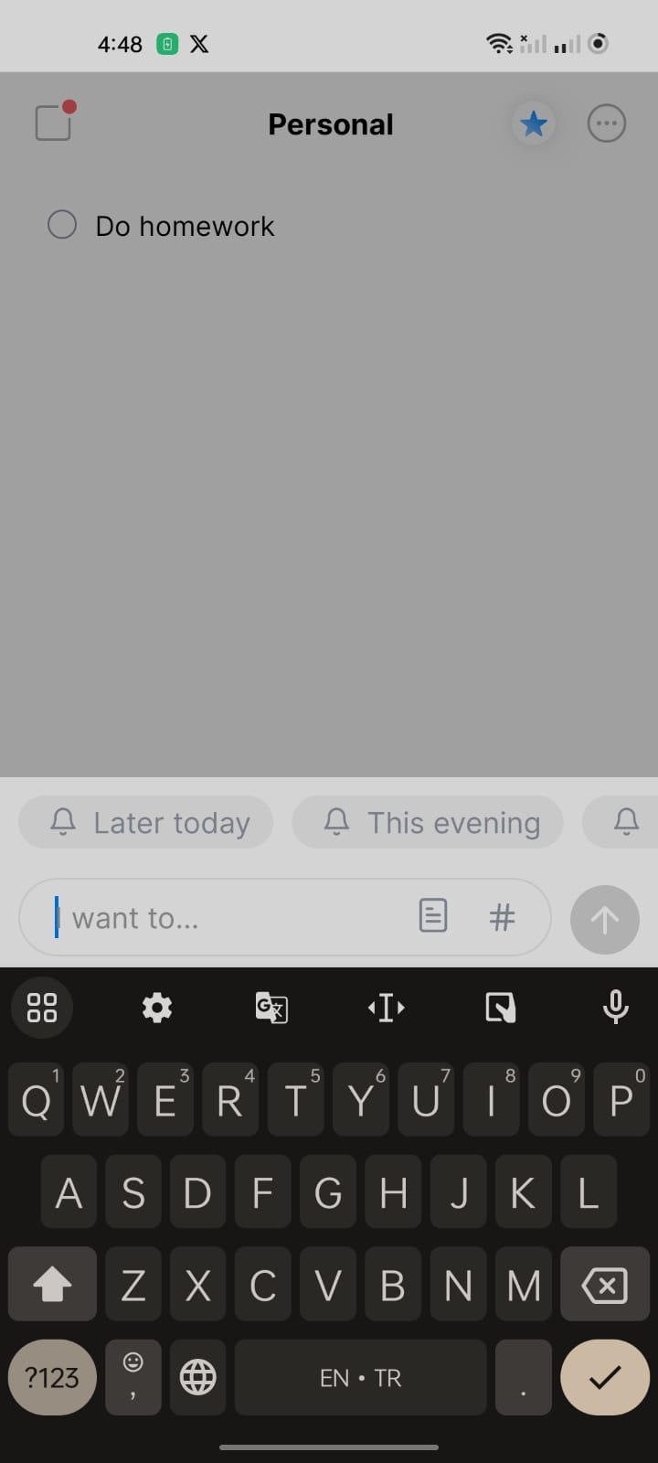

**Affected Devices:** iOS and Android

**Expected Result:** Users should be able to use speech to text for all task entries.

**Actual Result:** Only the first task can be entered using speech to text.

**Network:** Any

**Severity:** Low

**Priority:** Low

**Impact:** Confusing settings impact user understanding and app usability

Bug 6: iOS Page Orientation Issue

Description: When print daily tasks and changing the page orientation from vertical to horizontal on iOS, an unnecessary additional page is added.

**Reproducible Steps:**

1. Open the app on an iOS device.

2. Preview daily tasks to print it.

3. Change the page orientation from vertical to horizontal.

**Attachments:**

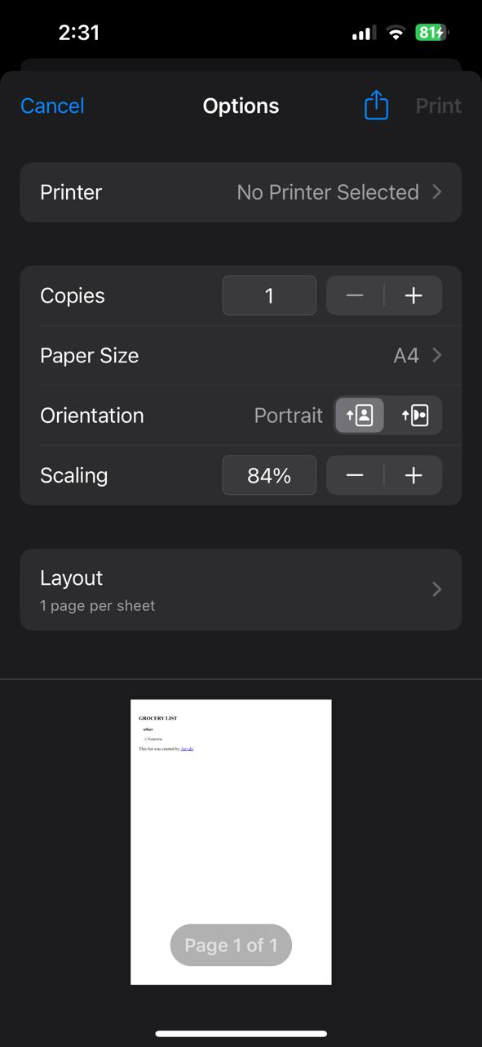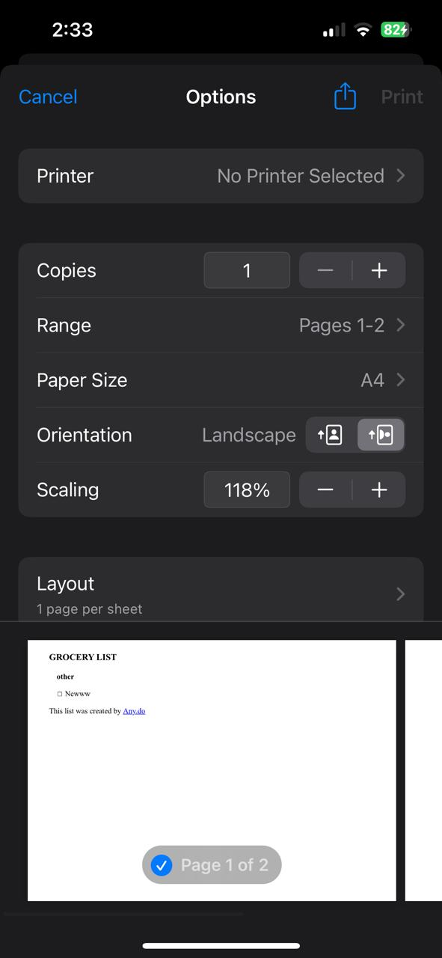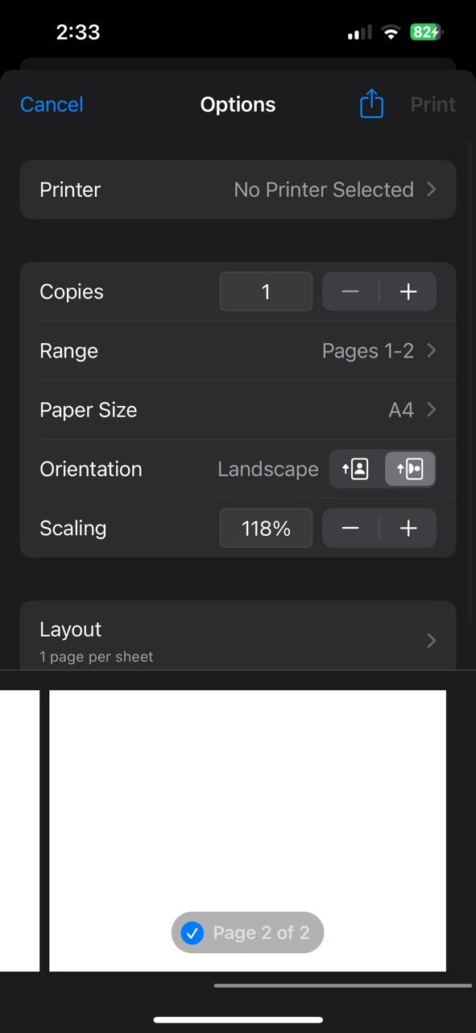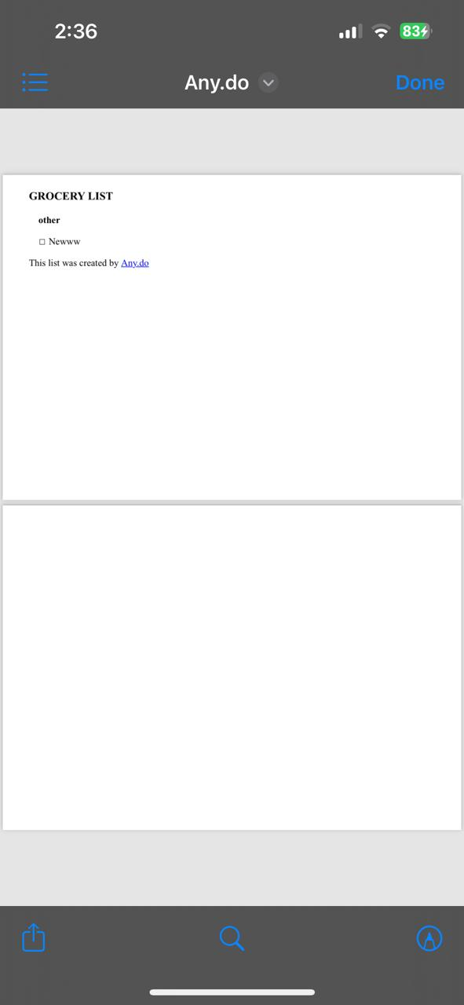

**Affected Devices:** iOS

**Expected Result:** The page layout should adjust correctly without adding extra pages.

**Actual Result:** An additional page is added for no reason.

**Network:** Any

**Severity:** Medium

**Priority:** Low

**Impact:** Printing issues cause inconvenience and waste of resources.

Bug 7: Teams Plan Navigation Issues

Description: When logging into Teams Plan, users face many unnecessary pages and many pages do not have back or skip buttons.

**Reproducible Steps:**

1. Open the app and log in.
2. Navigate to the "Teams Plan" section.
3. Observe the flow of pages presented during the login process.
4. Notice the absence of back or skip buttons on several pages

**Attachments:**

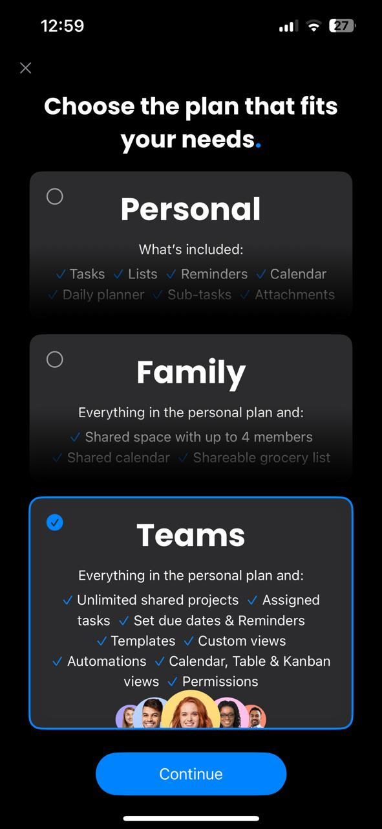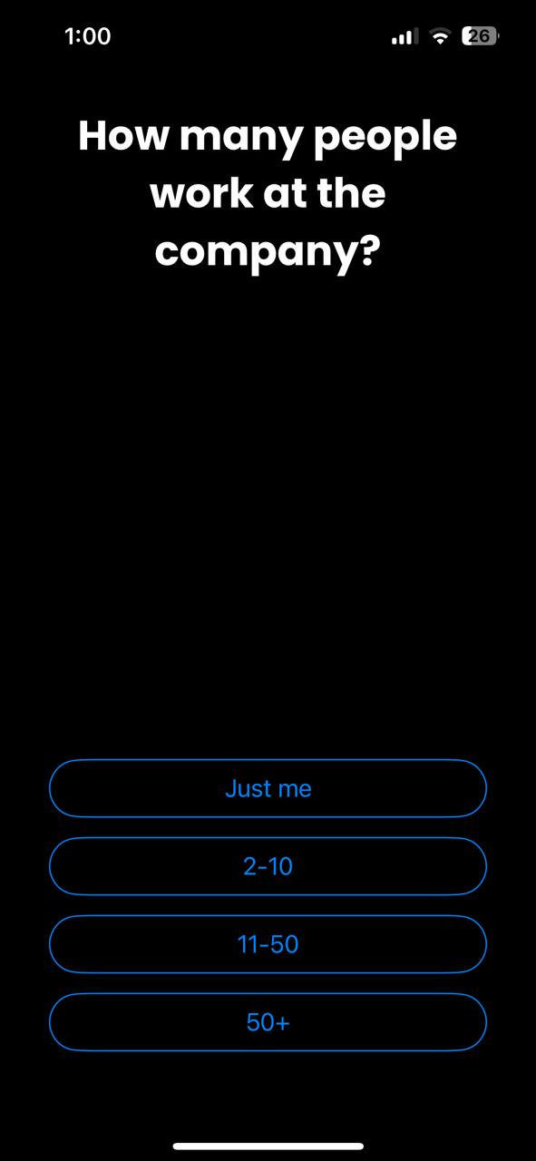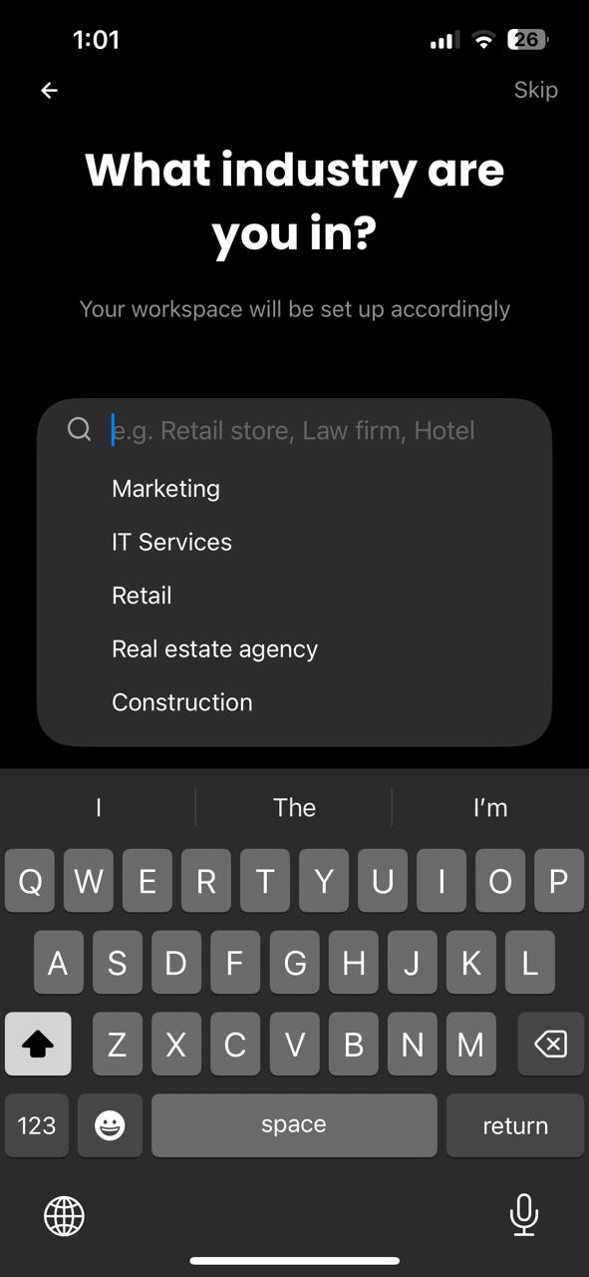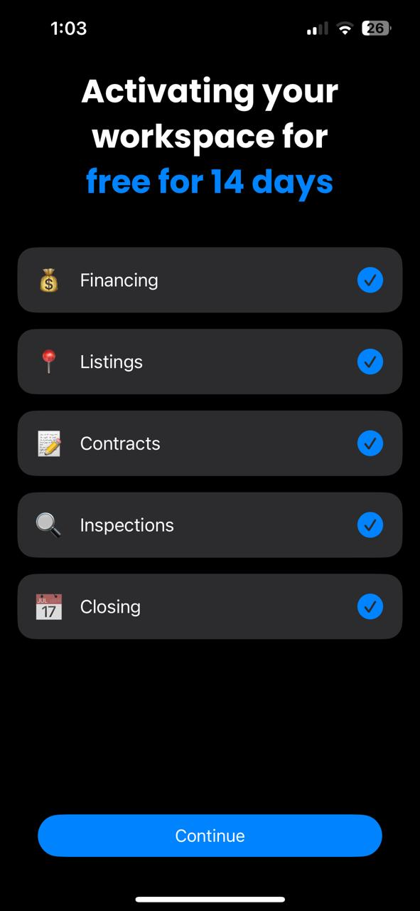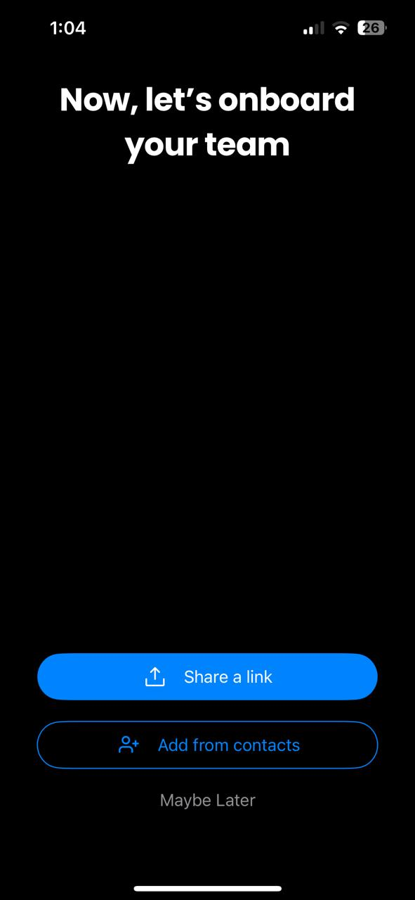

**Affected Devices:** iOS and Android

**Expected Result:** Each page should have a back or skip button for easy navigation.

**Actual Result:** Many pages lack back or skip buttons, making navigation cumbersome.

**Network:** Any

**Severity:** Medium

**Priority:** High

**Impact:** Users are forced to go through all pages, which may be time-consuming and frustrating, especially if the pages are not relevant to their immediate needs. The lack of navigation options (back or skip buttons) hinders user experience and may lead to user drop-off.

Addressing these bugs will significantly enhance the user experience of the Any.do mobile app. As a dedicated and experienced software tester, I am committed to ensuring the app meets the highest quality standards and provides a seamless experience for its users.